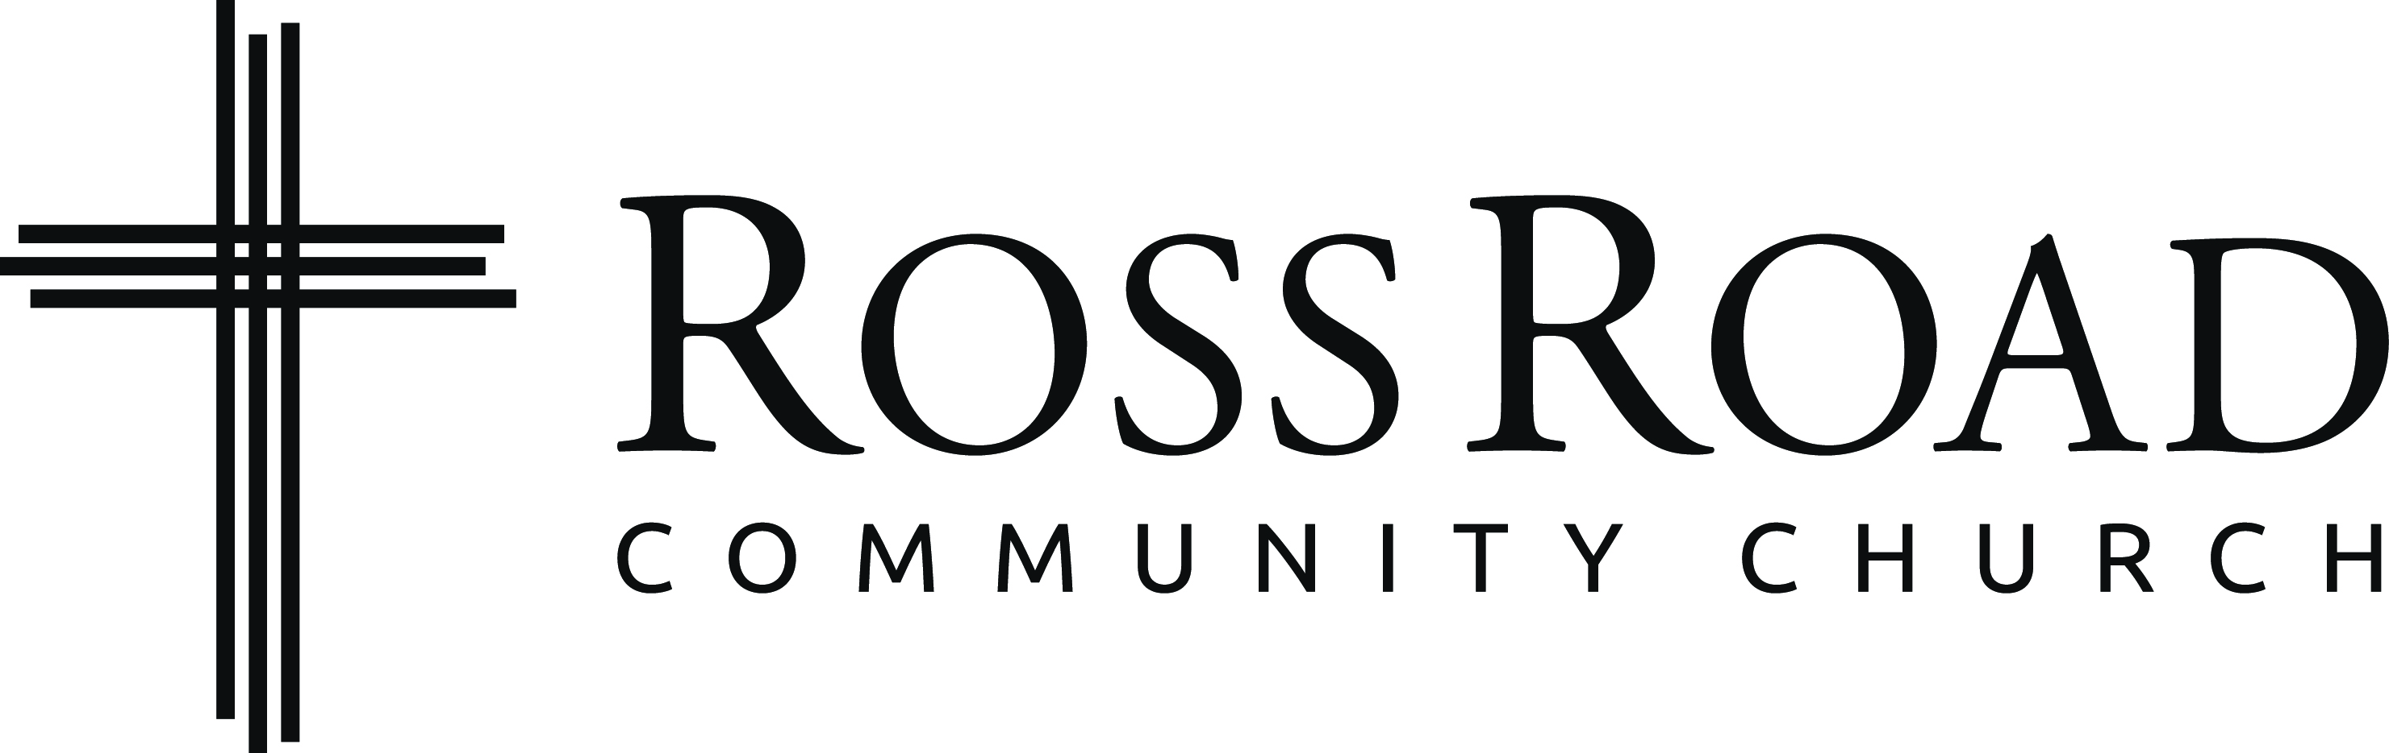
Facility Needs Assessment Insight Form
________________________________________________________________________________________________________________________

Thank you for taking the time to provide some insight about our facility needs as a church. At the outset it is important for us to remember that the church is not a building, the church is a community of people who walk together and live out God's redemptive purposes. We, as a church, are fortunate to have a building that we can use as a valuable ministry tool as we participate with God in His mission. Therefore, our building must be seen within this light, or else we lose focus on what matters most. Now with that said, we also have the responsibility to be good stewards of what God has given to us, and so we arrive at our present time needing to assess the usefulness of our current church facility. We are asking that you complete this needs assessment form, to assist in discerning present and future facility needs. Again, the building is a tool that provides a platform for ministry, in light of this would you please prayerfully read through our Mission, Vision, and Values and then complete the rest of this form. If you serve on a ministry team, please collaborate with your team on filling out this form.

Our Mission: Helping People Find and Follow Jesus

Our Vision: We envision a Spirit-led church of bold Christ followers, who are experiencing a new freedom in His love and are intentionally leading their friends, neighbors, and world to Him.

Our Values:

Dependence on God – Because we can do nothing without God, we joyfully celebrate Him in our worship and prayerfully depend on Him for everything.

Biblical Truth – Because our lives must be directed and our values shaped by the Bible, we embrace sound biblical teaching.

Outreach – Because people everywhere matter to God, we joyfully help them to find and follow Jesus through genuine relationships and Gospel witness.

The Next Generation – Because those of the next generation are a vital part of the church today and its leaders tomorrow, we accept, affirm, and equip them to live for God and to lead His church

Developing People – Because God desires all believers to be equipped to live out His call, we recognize gift-based ministry and leadership styles that empower individuals and teams.

Loving Community – Because life transformation happens in the context of loving relationships, we aim to be a welcoming redemptive community where we enjoy God and each other.

Risk-Taking Obedience - Because God desires our faith-filled obedience, we set aside fear of failure and personal preference to joyfully do His will. If we live by these values, we have every confidence our behavior will reflect them.

Please answer the questions below through the lens of the ministry in which you participate. At the end is a section for general comments where we’d appreciate your comments about the facility in general. If at all possible, please complete this form in Word Format, returning it by email to Pastor Darren at Darren@rossroadcc.ca before June 30th.

What about our present facility is advantageous to your ministry? (i.e., what’s working well for you?)

What about our present facility hinders your ministry’s potential?

In the next 1-2 years, what facility improvements would assist your ministry in reaching its potential?

In 5-10 years from now, what do you anticipate the facility needs of your ministry being?

General Comments:

In your experience of our facility, what would you highlight as our five greatest needs?

Do you feel that the current level of maintenance and improvement to the facilities is adequate for present and future ministry? Please explain.

3160 Ross Road, Abbotsford, BC V4X 1G4 Phone: 604-856-2024 info@rossroadcc.ca

